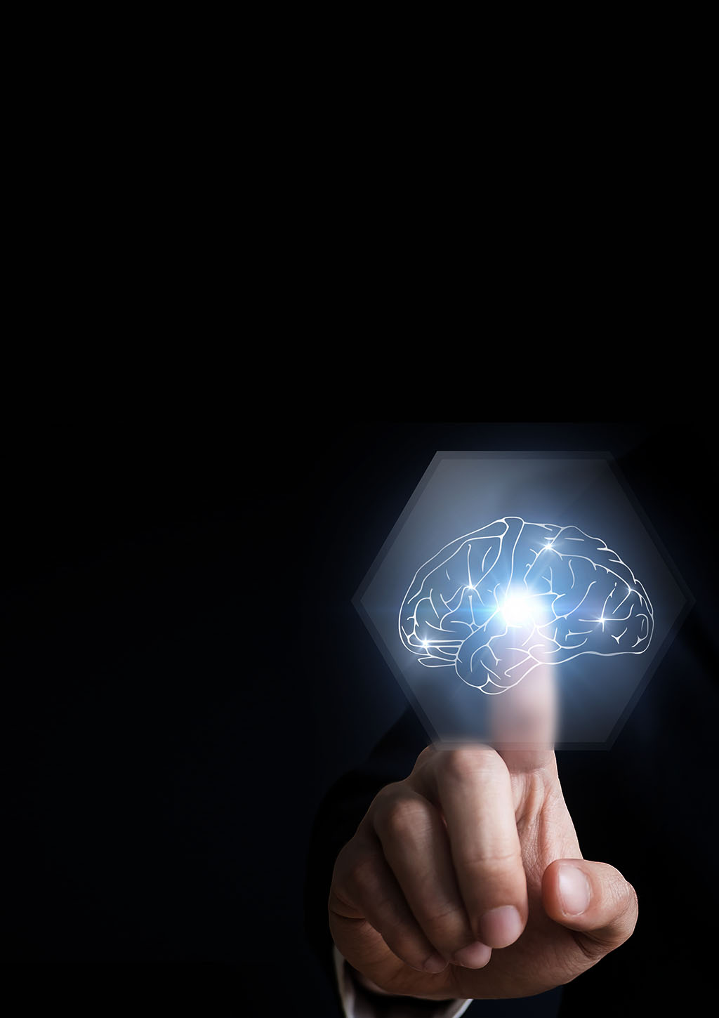

Report Topic: Artificial intelligence

Student Name : Asmaa Atef Mohamed Shafik

Seat Number : 190

Group : 2

Section: 9

B.N : 6

What is Artificial intelligence ?

**Artificial intelligence** (**AI**) is [intelligence](https://en.wikipedia.org/wiki/Intelligence) demonstrated by [machines](https://en.wikipedia.org/wiki/Machine), unlike the **natural intelligence** [displayed by humans](https://en.wikipedia.org/wiki/Human_intelligence) and [animals](https://en.wikipedia.org/wiki/Animal_cognition), which involves consciousness and emotionality. The distinction between the former and the latter categories is often revealed by the acronym chosen. 'Strong' AI is usually labelled as [artificial general intelligence](https://en.wikipedia.org/wiki/Artificial_general_intelligence) (AGI) while attempts to emulate 'natural' intelligence have been called artificial biological intelligence (ABI). Leading AI textbooks define the field as the study of "[intelligent agents](https://en.wikipedia.org/wiki/Intelligent_agent)": any device that perceives its environment and takes actions that maximize its chance of achieving its goals.[3] Colloquially, the term "artificial intelligence" is often used to describe machines that mimic "cognitive" functions that humans associate with the [human mind](https://en.wikipedia.org/wiki/Human_mind), such as "learning" and "problem solving".[4]

As machines become increasingly capable, tasks considered to require "intelligence" are often removed from the definition of AI, a phenomenon known as the [AI effect](https://en.wikipedia.org/wiki/AI_effect). A quip in Tesler's Theorem says "AI is whatever hasn't been done yet.” For instance, [optical character recognition](https://en.wikipedia.org/wiki/Optical_character_recognition) is frequently excluded from things considered to be AI, having become a routine technology. Modern machine capabilities generally [classified as AI include successfully understanding human speech,](https://en.wikipedia.org/wiki/Strategic_game) competing at the highest level in strategic [game systems (such as chess and Go), and also imperfect-information games like poker, self-driving cars, intelligent routing in](https://en.wikipedia.org/wiki/Self-driving_car) [content](https://en.wikipedia.org/wiki/Content_delivery_network) delivery networks[,](https://en.wikipedia.org/wiki/Self-driving_car) and [military](https://en.wikipedia.org/wiki/Military_simulations) simulations[.](https://en.wikipedia.org/wiki/Self-driving_car)

Artificial intelligence was founded as an academic discipline in 1955, and in the years since has experienced [several waves of optimism, followed by disappointment and the loss of funding (known as an "AI winter"), followed by new approaches, success and renewed funding.](https://en.wikipedia.org/wiki/AI_winter) [After](https://en.wikipedia.org/wiki/AI_winter) [AlphaGo](https://en.wikipedia.org/wiki/AlphaGo) [defeated a](https://en.wikipedia.org/wiki/AI_winter) professional Go player in 2015, artificial intelligence once again attracted widespread global attention. For most of its history, AI research has been divided into sub-fields that often fail to communicate with each other. These sub-fields are based on technical considerations, such as particular goals (e.g. "[robotics](https://en.wikipedia.org/wiki/Robotics)" or "[machine learning](https://en.wikipedia.org/wiki/Machine_learning)"), the use of particular tools ("[logic](https://en.wikipedia.org/wiki/Logic)" or [artificial neural networks](https://en.wikipedia.org/wiki/Artificial_neural_network)), or deep philosophical differences. Sub-fields have also been based on social factors (particular institutions or the work of particular researchers).

The traditional problems (or goals) of AI research include [reasoning](https://en.wikipedia.org/wiki/Automated_reasoning), [knowledge representation](https://en.wikipedia.org/wiki/Knowledge_representation), [planning](https://en.wikipedia.org/wiki/Automated_planning_and_scheduling), [learning](https://en.wikipedia.org/wiki/Machine_learning), [natural language processing](https://en.wikipedia.org/wiki/Natural_language_processing), [perception](https://en.wikipedia.org/wiki/Machine_perception) and the ability to move and manipulate objects. AGI is among the field's long-term goals. Approaches include statistical methods, computational intelligence, and traditional symbolic AI. Many tools are used in AI, including versions of search and mathematical optimization, artificial neural networks, and methods based on statistics, probability and economics. The AI field draws upon [computer science](https://en.wikipedia.org/wiki/Computer_science), [information engineering](https://en.wikipedia.org/wiki/Information_engineering_(field)), [mathematics](https://en.wikipedia.org/wiki/Mathematics), [psychology](https://en.wikipedia.org/wiki/Psychology), [linguistics](https://en.wikipedia.org/wiki/Linguistics), [philosophy](https://en.wikipedia.org/wiki/Philosophy), and many other fields.

The field was founded on the assumption that human intelligence "can be so precisely described that a machine can be made to simulate it". This raises philosophical arguments about the mind and the ethics of creating artificial beings endowed with human-like intelligence. These issues have been explored by [myth](https://en.wikipedia.org/wiki/History_of_AI" \l "AI_in_myth%2C_fiction_and_speculation), [fiction](https://en.wikipedia.org/wiki/Artificial_intelligence_in_fiction) and [philosophy](https://en.wikipedia.org/wiki/Philosophy_of_AI) since [antiquity](https://en.wikipedia.org/wiki/Ancient_history). Some people also consider AI to be [a danger to humanity](https://en.wikipedia.org/wiki/Existential_risk) if it [progresses](https://en.wikipedia.org/wiki/Technological_unemployment" \l "21st_century) unabated. [Others](https://en.wikipedia.org/wiki/Technological_unemployment" \l "21st_century) believe that AI, unlike previous technological revolutions, will create a risk of mass unemployment.

# Challenges

The cognitive capabilities of current architectures are very limited, using only a simplified version of what intelligence is really capable of. For instance, the human mind has come up with ways to reason beyond measure and logical explanations to different occurrences in life. What would have been otherwise straightforward, an equivalently difficult problem may be challenging to solve computationally as opposed to using the human mind. This gives rise to two classes of models: structuralist and functionalist. The structural models aim to loosely mimic the basic intelligence operations of the mind such as reasoning and logic. The functional model refers to the correlating data to its computed counterpart. The overall research goal of artificial intelligence is to create technology that allows computers and machines to function in an intelligent manner. The general problem of simulating (or creating) intelligence has been broken down into sub-problems. These consist of particular traits or capabilities that researchers expect an intelligent system to display. The traits described below have received the most attention.

### Reasoning, problem solving

### Knowledge representation

### Planning

### **Machine** Learning

### Natural language processing

### Perception

### Motion and manipulation

### Social intelligence

### General intelligence

# Approaches

No established unifying theory or [paradigm](https://en.wikipedia.org/wiki/Paradigm) guides AI research. Researchers disagree about many issues.[f] A few of the most long-standing questions that have remained unanswered are these: should artificial intelligence simulate natural intelligence by studying [psychology](https://en.wikipedia.org/wiki/Psychology) or [neurobiology](https://en.wikipedia.org/wiki/Neuroscience)? Or is [human biology](https://en.wikipedia.org/wiki/Human_biology) as irrelevant to AI research as bird biology is to [aeronautical engineering](https://en.wikipedia.org/wiki/Aeronautical_engineering)?[23] Can intelligent behavior be described using simple, elegant principles (such as [logic](https://en.wikipedia.org/wiki/Logic) or [optimization](https://en.wikipedia.org/wiki/Optimization_(mathematics)))? Or does it necessarily require solving a large number of unrelated problems?[24]

### Cybernetics and brain simulation

### Symbolic

### Cognitive simulation

### Logic-based

### Anti-logic or scruffy

### Knowledge-based

### Sub-symbolic

### Embodied intelligence

### Computational intelligence and soft computing

### Statistical

### Integrating the approaches

### Intelligent agent paradigm

### [Agent architectures](https://en.wikipedia.org/wiki/Agent_architecture) and [cognitive architectures](https://en.wikipedia.org/wiki/Cognitive_architecture)

# Applications

AI is relevant to any intellectual task. Modern artificial intelligence techniques are pervasive and are too numerous to list here. Frequently, when a technique reaches mainstream use, it is no longer considered artificial intelligence; this phenomenon is described as the AI Effect

High-profile examples of AI include autonomous vehicles (such as drons and self-driving cars ), medical diagnosis, creating art (such as poetry), proving mathematical theorems, playing games (such as Chess or Go), search engines (such as [Google Search](https://en.wikipedia.org/wiki/Google_Search)), online assistants (such as Siri in IPhone and Sam the new Samsung Virtual Assistant ), image recognition in photographs, spam filtering, predicting flight delays, prediction of judicial decisions, targeting online advertisements, and energy storage

With social media sites overtaking TV as a source for news for young people and news organizations increasingly reliant on social media platforms for generating distribution,major publishers now use artificial intelligence (AI) technology to post stories more effectively and generate higher volumes of traffic.

AI can also produce [Deepfakes](https://en.wikipedia.org/wiki/Deepfake), a content-altering technology. ZDNet reports, "It presents something that did not actually occur," Though 88% of Americans believe Deepfakes can cause more harm than good, only 47% of them believe they can be targeted. The boom of election year also opens public discourse to threats of videos of falsified politician media.

# **Screen Shots**





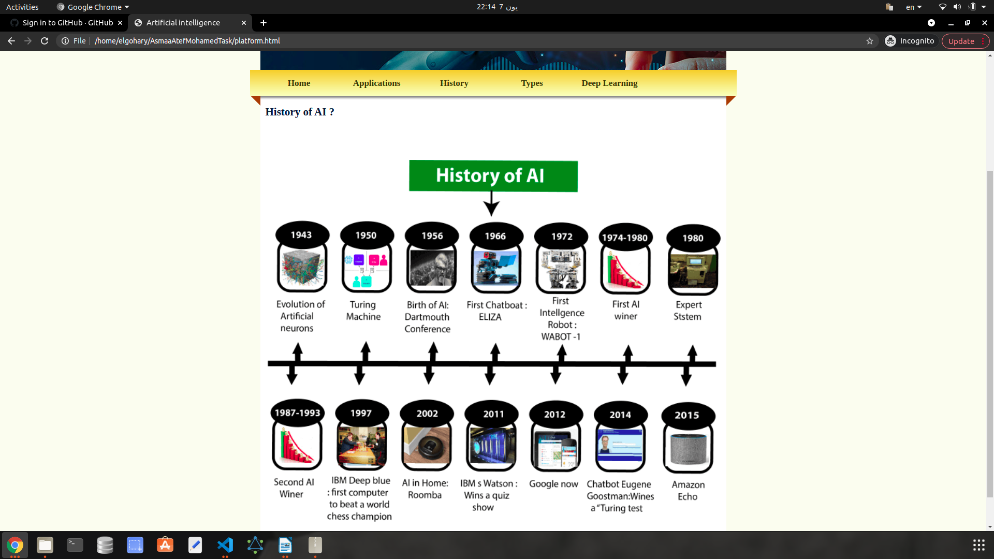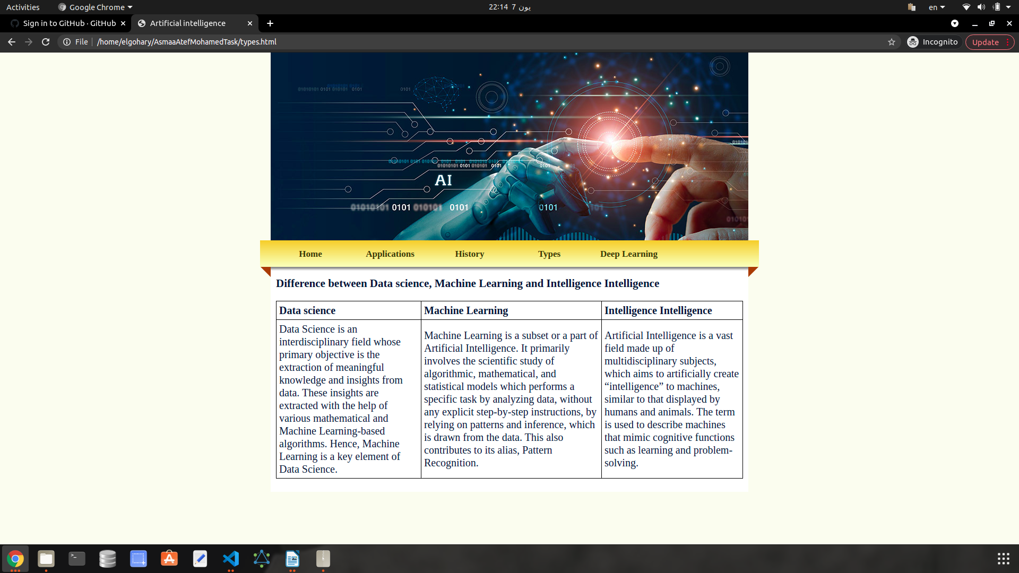

# **Source Code of index page**

<!DOCTYPE html>

<html xmlns="http://www.w3.org/1999/xhtml">

<head>

<meta http-equiv="Content-Type" content="text/html; charset=utf-8" />

<link rel="stylesheet" type="text/css" href="style.css" />

<title>Artificial intelligence</title>

</head>

<body>

<div id="container">

<div id="mainpic"></div>

<div id="menu">

<ul>

<li class="menuitem"><a href="index.html">Home</a></li>

<li class="menuitem"><a href="apps.html">Applications</a></li>

<li class="menuitem"><a href="platform.html">History</a></li>

<li class="menuitem"><a href="types.html">Types</a></li>

<li class="menuitem">

<a href="deepLearning.html">Deep Learning</a>

</li>

</ul>

</div>

<div id="content">

<h2>What is Artificial Intelligence (AI)?</h2>

<p>&nbsp;</p>

<p>&nbsp;</p>

<img

class="contentImg"

src="images/Human-Intelligence-Can-Fix-AI-Shortcomings-1.jpg"

/>

<p>

Artificial intelligence (AI) is a wide-ranging branch of computer

science concerned with building smart machines capable of performing

tasks that typically require human intelligence. AI is an...

</p>

<p>&nbsp;</p>

<p>&nbsp;</p>

<h2>Artificial General Intelligence</h2>

<p>&nbsp;</p>

<p>&nbsp;</p>

<p>

Artificial General Intelligence The creation of a machine with

human-level intelligence that can be applied to any task is the Holy

Grail for many AI researchers, but the quest for AGI has been fraught

with difficu</p>

</div>

</div>

</body>

</html>